An E-mail

*Raindrops slithered through the window panes of Kabir’s house followed by regular intervals of flashing lights through it.*

*Kabir an obsessed coder with thick glasses covered in a fancy frame on both side of his nose. There was a showcase of lines running back to his temples from the corner of his eyes when he smiled and throbbing veins on the left side of his forehead. He had a perfect jawline, well-structured teeth, almond-shaped eyes and an eagle’s beak shaped nose,*

Kabir- *(looking at the photograph of Ganesh)* Hey just stop taking my pictures, I am not a photogenic personality. Ok just stop that friggin’ thundering, I cannot concentrate on my e-mail draft!

*Another flash and this time Kabir knew it was not a natural one, This was a yellow color flashing and a repetitive one. He knew what it was and also presumed what will happen in few minutes.*

*Engine turned off and there was a sharp and clear noise slamming of a car door.*

*A female voice from Kabir’s doorbell repeated: “open the door please”. Kabir knew who it was. He opened*

Kabir- It’s him again, right? Neha it’s been a year now and you are still stumbling upon him. Can’t you just stop now? You have experienced this shit for more than 3 times and for how many times you want to experience it?

*In between the rainwater beads on her face, Kabir noticed water coming out from her blue eyes. She was drenched from top to bottom struggling with her wet highlighted hair. She was wearing a black top tank shirt followed by a camel-colored pallazo and 3 inched heels.*

Neha- Will you let me in or you want to experience 3 inched heels on your face?

Kabir- come on in and just be dry, till then I will prepare ‘the Neha Sabrawal’s special coffee’.

Neha- Extra strong espresso with frothed steamed milk. Not bad Mr. Kabir!

Kabir- Are you wearing my sweatshirt? Seriously mam are you my girlfriend? *(grinning)*

Neha- Kabir, Don’t force me to speak again that sentence……*(Kabir interrupting)*

Kabir- Ok ok I don’t want to hear that, I told you that I am happy in this and have accepted my fate. Tell me what happened now with you and that freak?

Neha- He is my boyfriend Kabir! Don’t use this type of words, please

Kabir- Was! Wait a minute; did you just approach him for a patch up? Don’t tell me this.

Neha- you know that I love him! And I am totally in him.

Kabir- How many times I have asked you that ‘did he justified this I LOVE YOU thing with you?’ but no, only you want is him, no matter how much and how many times he attacks your character and self- respect in front of the public. Ok, what happened this time?

Neha- He mocked my parents in front of his friends know that I am present there. All I could be only beg and demanded to stop, but…… so I left and you know the rest.

Kabir- On what speed you came here?

Neha- *(making an innocent face)* speed was enough to not operate airbags properly if an accident occurred

Kabir- Good! Shabash.

Neha- Can you please stop it! I have phoned mom and informed that I am here tonight as I cannot drive this distance alone in this rain.

Kabir- No problem. But I am not sacrificing my double cushioned bed for you huh *(inside he wanted to sleep on that bed with her for a lifetime)* You can adjust yourself in this double mattress sofa. *(Chuckling)*

Neha- I know you Dumbo, Just give me one pillow.

*(Kabir went to his room after making sure that Neha is in her dreams while walking back to his room, he felt moisture in his eyes. He knew what and who was the reason behind his tears)*

Kabir(to himself)- Don’t cry you puny creature, she thinks of you as her best friend and nothing else. She can’t give you that special feeling. You have to accept the fact, please! Just take your imaginary Neha (pillow) and sleep. You got a work to finish tomorrow. Don’t screw up your friendship just by asking her up.

*(in between all this he forgot his phone on the table beside his sofa.)*

*Neha was disturbed by the regular beeping of Kabir's phone and was now awakened. She decided to check his phone. Here’s the turning point.*

*Call it Kabir's luck or a coincidence, when she unlocked his phone, an email draft opened on which he was working. She started reading……*

*E-mail id flashed something like this* [***nka2010@gmail.com***](mailto:nka2010@gmail.com)*.*

*He was writing his story in the mailbox and saved them in drafts. Actually, it was a collection of events and situations in which how he met Neha and experiences how he fell for her. How he felt vulnerable and lonesome when he came to know about the relationship of Neha and that freak.*

*She cried and cried hard after reading each mail drafts. She realized how dumb and stupid she was that she couldn’t see this never-ending and one-sided love of him. She cried because there was a sense of realization that she was in a one-sided relationship with the freak.*

*Kabir opened his eyes and saw Neha with a plate of breakfast in her hands exactly in front of him.*

Kabir- You! Seriously Ms. Neha laid back Sabrawal made a breakfast for me! Am I on Mars or the sunrise from the west?

*She settled beside him on the bed and started pouring tea into the cup. Kabir had no idea what on earth was going on and why her demeanor was strange.*

Kabir- Neha you don’t have to do this……. *(Neha kept her finger in his mouth and stopped him)*

*She slightly murmured* [*nka2010@gmail.com*](mailto:nka2010@gmail.com) *and Kabir came to know what was the scene. He hesitated and searched for his phone. There was no point in searching as it was with Neha. Neha showed him his phone and slightly backed off so as he can’t snatch it away from her.*

Kabir- See there is no such thing as you are thinking. Just forget all this. That mail id is just for time pass and to check my potential that up to which extent my imagination can go. This pillow is just for the feeling of contentment.

Neha- Next time you lie to me please try fewer details. And I didn’t talk anything about the pillow! So Mr. Kabir, as I have read all the emails and also seen you all messed up, I think I can spend my life walking beside you hand in hand.

*Kabir couldn’t imagine this and asked her to pinch him so that he could confirm he was in reality. Instead, she punched him. He finally opened his arms to welcome* ***the most beautiful girl he had ever met in his life*** *in it.*

Neha- (still in his arms) Acha Kabir, what’s nka in that mail id?

Kabir- Neha Kabir Ahluwalia. (Laughing)

Neha- 2010? Let me guess, one second, oh shit you freaking creature, yours and mine birth-dates! And this pillow, an imaginary Neha? Right?

Kabir- Any doubts

Neha- How many times you have imagined you and me getting married?

Kabir- 15

*(Both giggled)*

From then Neha filled the gaps between Kabir’s fingers…..

Mails:-

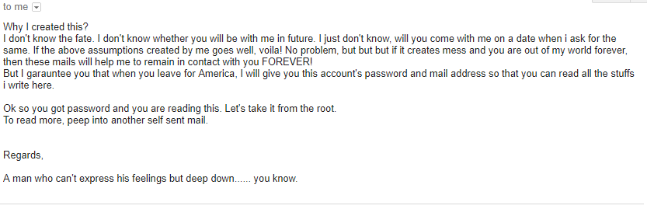



And these types of drafts continued in his mailbox. These are just examples to make the picture clear.

Above is just a work of fiction. There is no resemblance in real life.

Regards,

Kintu